Pass for level 24: OsRmXFguozKpTZZ5X14zNO43379LZveg

Step 1:Login to natas 23

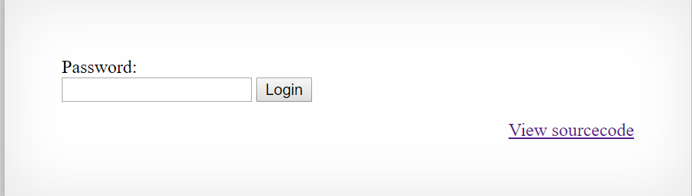

Step 2:View source code

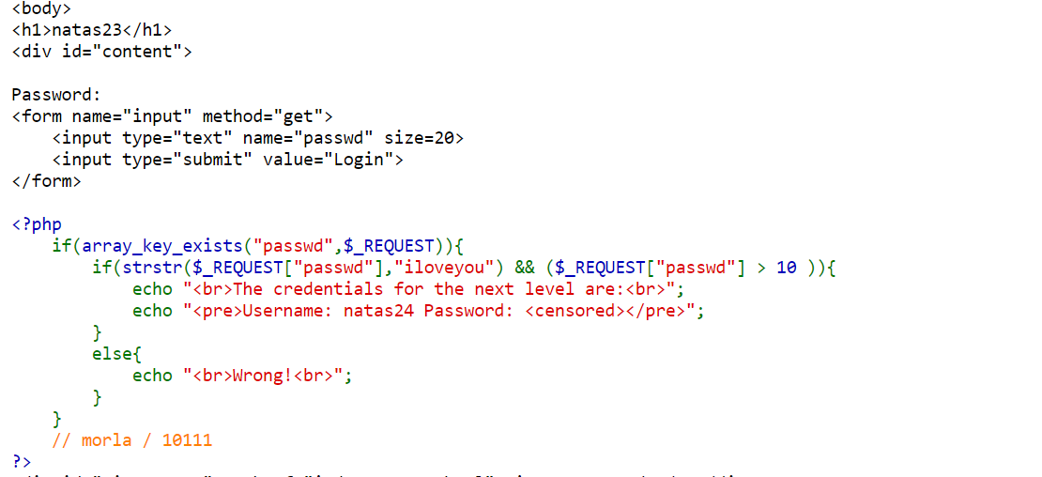

Step 3: Using type juggling

In php variable use by context so if I will set passwd to 11iloveyou

Arithmetic operations will use the number 10 and string operation will use the string "iloveyou".

So I will inject that to the code and see what the password for the next level.

